Copyright for test papers and marking guides remains with *West Australian Test Papers.*

They may only be reproduced within the purchasing school according to the advertised Conditions of Sale.

Test papers should be withdrawn after use and stored securely in the school until Friday 5th December 2014.



## PHYSICS

## YEAR 11

## 2A/2B

**2014**

**SOLUTIONS**

**Section 1: Short Answers**

Question 1 (2 marks)

The announcer is using the Kelvin scale of temperature instead of the usual Celsius scale. In fact the temperature on the Celsius scale would be (-273 + 40 = -233 oC) which would be far too cold to be anywhere, let alone at the beach.

Question 2 (2 marks)

Q = m c T = 0.5 x (4.18 x 103) x 80 = 1.672 x 105 J

Q = m L = 0.5 x (2.26 x 106) = 1.13 x 106 J

Total quantity of heat = 1.3 x 106 J

Question 3 (3 marks)

The girl is receiving a very large electrical charge from the machine and because she is insulated from the earth, the charge accumulates on the outside of her body. The dry strands of her hair become individually charged with like charge (most likely negative). The like charge repels each hair so the hair stands up and separate.

Question 4 (2 marks)

(a) let upwards be positive

u = 0 m s-1

a = ?

v =23 m s-1

s = 33.0 m

v2 = u2 + 2 a s

232 = 02 + 2 x a x 33

529 = 0 + 66 a

66 a = 529

a = 8.02 m s-2 (2 marks)

(b) Total energy at point A = mgh

= 6000 x 9.8 x 30

= 1.764 x 106 J

Total energy at point B = m g h + ½ m v2

= (6000 x 9.8 x 25) + [½ x 6000 x (5000/3600)2]

= 1.47 x 106 + 5.788 x 103

= 1.476 x 106 J

Loss of energy = (1.764 - 1.476) x 106 = 2.88 x 105 J

Percentage energy loss = (2.88 x 105) / (1.764 x 106) x 100

= 16.3% (4 marks)

Question 5 (6 marks)

(a)

u = 0 ms-1

v = ?

s = 5.00 m

a = 9.80 m s-2

v2 = u2 + 2 a s

v2 = 02  + 2 x 9.8 x 5 = 98

v = (98)1/2

speed when the branch hits the ground = 9.90 m s-1 (2 marks)

(b)

I = F t = mΔv

F x 0.300 = 120 x 9.9

F = (120 x 9.9) / 0.300

F = 3960 N (1 mark)

Question 6 (3 marks)

1. Activity = decays/sec

Act = 468/60x60

Act = 0.13Bq (2 marks)

1. The activity has decreased by a half therefore the wood from the tomb is 5730 years old
2. Mark)

Question 7 (6 marks)

(a)

I = q/t = 2.5 = q / (3.0 x 60 x 60)

Quantity of charge (q) = 2.5 x (3.0 x 60 x 60)

= 2.70 x 104 C (2 marks)

(b)

Number of electrons = q / (1.6 x 10-19)

= 2.70 x 104 / (1.6 x 10-19)

=1.69 x 1023 electrons (2 marks)

(c)

Work = 18 x 2.5 x (3 x 60 x 60)

Work done in moving the charge = 4.86 x 105 J (2 marks)

Question 8 (4 marks)

Estimate the area of the girl exposed to the Sun = 1.6 x 0.3 = 0.48 m2

Estimate mass of girl = 50 kg

Radiation reaching her per second = 900 x 0.48 = 432 J

Heat from Sun = Heat absorbed by girl

432 x time = m c T

432 x time = 50 x 3500 x 2

time = (50 x 3500 x 2) / 432

time =810 s = 13.50 min

Accept any answers based on reasonable assumptions of girl’s body area and mass

Question 9 (4 marks)

Determine the acceleration of the floor safe?

**Fnet = F1 + F2**

**Fnet = 10.0 + 12.0 (1 mark)**

**Fnet = 22.0 N**

**Fnet = ma**

**m = 225 kg a =**

**a = ?**

**a = 0.978 m s-2 (1 mark)**

If the safe were replaced by a force measuring scale and the spies maintained their original forces, determine the reading on the scale. (Hint: a vector diagram might help you!)

**Fdif = │F1 - F2│**

**Fdif = │10.0 – 12.0│**

**Fdif = 2.00 N apart (1 mark magnitude & direction)**

Question 10 (4 marks)

(a)

The number of half lives = 3

If one half life is 1.28 x109 years

Three half lives = 3 x 1.28 x 109

= 3.84 x 109 years. (2 marks)

(b)

An extremely long half life would mean that only a very slight change in the mass or activity would be observable in a short period of time. This would be difficult to measure and distinguish from minor changes in background radiation. (2 marks)

Question 11 (4 marks)

(a)

Equation 1 131I53 🡪 131Xe54 + 

Equation 2 131Xe54 🡪 131Xe54 +  (2 marks)

(b)

Iodine-131 has a relatively short half life so will not be active in the body for long (2 marks)

(c)

(0.008 x 20) + (0.012 x 1)

0.16 + 0.012 = 0.172 mSv

In 25 days the dose equivalent is 25 x 0.172 = 4.3 mSv (2 marks)

Question 12 (4 marks)

(a)

The earth pin is connected to the earth wire which in turn is connected to a conducting component in the appliance. In the event of an active wire accidently touching the conducting component of the appliance, the current will run to earth rather than through the user, thus preventing an electric shock. (2 marks)

(b)

Appliances that are made mainly of non conducting materials and constructed in such a way that even if an active wire touched the body of the appliance it would be unlikely that the current would flow to the user of the appliance. (2 marks)

Question 13 (6 marks)

(a)

Let upwards be positive then:

u = 15.0 m s-1

a = -9.8 m s-2

s = -58 .0 m

s = u x t + ½ a t2

-58 = 15 x t + ½ x (-9.8) x t2

4.9 t2 -15 t - 58 = 0

t = 15 ± [(-15)2 - (4 x 4.9 x -58)]1/2

(2 x 4.9)

t = 15 ± (225 +1136.8)1/2

t = 15 ± 36.9 Disregard the negative value of time

9.8 Time taken for the ball to hit the ground = 5.30 s

(b)

v2 = u2 + 2 a s

v2 = 152 + (2 x 9.8) x (-58)

v2 = 225 + (2 x 9.8) x (-58)

v2 = 1362

v = 36.9 m s-1

The ball’s speed on impact is36.9 m s-1 downwards (2 marks)

**END OF SECTION 1**

Question 14 (4 marks)

(a) Quantity of heat required to melt the ice at 0 oC:

Q = m L = 1.25 x (0.2 x 3.34 x 105) J = 8.35 x 104 J (1 mark)

(b) Time taken to melt the ice:

P = E/t so time = E/P (2 marks)

Time = (8.35 x 104) / 300 = 278 s (= 4.64 min)

(c) Quantity of energy required to heat the water from 0oC to 100oC:

Q = m x c x ΔT

Q = 1.25 x [(0.2 x (4.18 x 103) x 100] = 1.04 x 105 J (2 marks)

(d) Time taken to heat the water to 100oC:

P = E/t so time = E/P

Time = (10.45 x 104) / 300 = 348.3 s = 5.81 min (2 marks)

Total time = 4.64 + 5.81 = 10.4 min

OR =278.3 + 348.3

= 627s

(e) (2 marks)

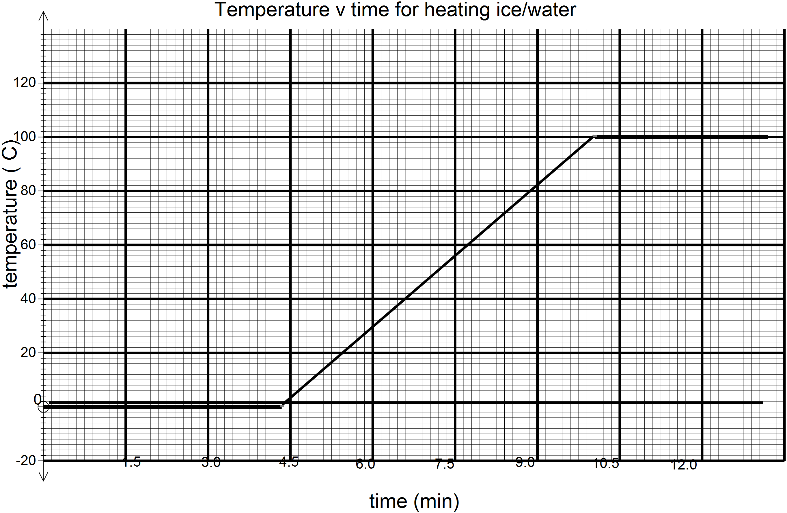

Question 15 (12 marks)

(a) (i) Lift could be moving up or down (accelerating downwards or decelerating upwards). (2 marks)

(ii) Lift is accelerating downwards. (1 mark)

(b) (i) The lift could be moving up or down (decelerating downwards or accelerating upwards. (2 marks)

(ii) Lift is accelerating upwards. (1 mark)

(c) (i) The lift could be moving either upwards or downwards. (2 marks)

(ii) The lift is moving at constant velocity. (1 mark)

(d) F = mg - m a

400 = 490 – 50 a

so a = 90 / 50 = 1.8 m s-2

Acceleration is 1.8 m s-2 downwards (3 marks)

Question 16 (9 marks)

(a)

It is likely that the plastic thickness has decreased allowing a greater quantity of radiation to pass through it. (2 mark)

(b)

Beta radiation can be stopped from penetrating thin sheets of aluminium so the MINIMUM protection would be for the source to be housed in a covering of aluminium. (2 marks)

(c)

0 to 5.3 years = 5.3 years

5.3 to 10.6 years = 5.3 years

10.6 to 15.9 years = 5.3 years

Average = 15.9 / 3 = 5.3 years

The half life is 5.3 years (3 marks)

(d) Yes

The beta emitter would produce radiation that would penetrate the plastic and a half life of

5.3 years would be suitable as the source would not need to be changed too often. (2 marks)

Question 17 (8 marks)

(a)

 (3 marks)

(b)

a = 4.5 / 3.5 m s-2

= 1.29 m s-2 (1 mark)

(c)

F = m x a

F = 2.5 x 1.29 = 3.23 N (1 mark)

(d)

E = ½ m v2

E = ½ x 2.5 x 4.52 = 25.3 J (2 marks)

(e)

P = E / t = ½ m v2 / t

P = ½ x 2.5 x 4.52 / 3

= 8.44 W (2 marks)

Question 18 (10 marks)

(a) m1u1 + m2u2 = m3v

1200x20 + 750x-15 = 1950xv2

V2 = 6.54 ms-1 in direction of 1200kg car (3)

(b) change in p = mv-mu

750x6.54 - 750 x-15

= 1.62x104 kgms-1 (2)

(c) F=mv-mu/t

1950x0-1950x6.54/1.5

F=-8.5x103 ms-1 (3)

(d) airbags increase the time the change in momentum occurs which reduces the force

(2)

Question 19 (13 marks)

Question 20 (8 marks)

(a)

235U92 + 1n0  140Xe54 + 94Sr38 +21n0 (2 marks)

(b)

Reactants Products

235.04392 139.90544

1.008665 93.906378

1.008665

1.008665

Totals 236.052585 µ - 235.829148 µ

Mass defect = 236.052585 - 235.829148 = 0.223437 µ

Energy released = 0.223437 x 931 = 208.019847 MeV or 3.328 x 10-17 MJ (3 marks)

OR 3.328 x 10-11 J

(c)

Power consumption = 5.0 x 1018 J per month

Number of decays = (5 x 1018) / (3.328 x 10-11) = 1.502404 x 1029

1 decay requires 235.04392 x 1.66 x 10-27 kg of uranium

= 3.9017 x 10-25 kg

(1.502404 x 1029) x (3.9017 x 10-25) = 5.86 x 104 kg (3 marks)

Question 21 (11 marks)

1. Circle 1: ‘V’ as the circle represents a voltmeter connected in parallel across the

component it is measuring potential difference. (2 mark)

1. Circle 2: ‘A’ as the circle represents an ammeter connected in series with components to

measure the current flowing through the component. (2 mark)

1. 1/R = 1/R1 + 1/R2

1/6 = 1/8 + 1/R

1/R = 1/6 - 1/8

1/R = (4 - 3)/24

R = 24 Ω (2 marks)

1. On the diagram the arrow would be pointing away from the negative terminal of the

power supply. (1 mark)

1. If the total resistance of the circuit is 16 Ω then R3 has a resistance of:

16 - (2 + 6 ) = 8 Ω (2 marks)

(f) V = I x R

9 = I x 16

I = 9 / 16 = 0.56 A (2 marks)

**END OF SECTION 2**

**Section 3:**

Question 22 (16 marks)

1. Ionisation is the separation of an electron from an air molecule. This leaves a positively

charged ion and a negatively charged electron. (2 marks)

1. 241Am95 🡪 237Np93 + 4He2 (2 marks)

note: The equation could include gamma radiation as a product (γ)

1. The smoke particles absorb the alpha particle’s energy and therefore the alpha

particles are less able to ionise in air. (2 marks)

1. Smoke would not stop beta or gamma radiations yet alpha particles are stopped by

smoke. Alpha particles are less penetrating and therefore safer for the user. (3 marks)

1. There is a very small quantity (0.3 µg) of the sample of americium-241 that is capable of emitting gamma radiation and only 1% of all radiation emitted is gamma. (1 mark)

(f) The time taken for the activity of a radioactive source to halve. (2 marks)

(g) So that the device can be used for a relatively long time without the

radioisotope requiring replacement. (2 marks)

(h) Alpha particles are stopped by a few centimetres of air and certainly by the

plastic covering so the radiation is contained within the detector. (2 marks)

**END OF QUESTIONS**